Company Name:
Cartio Therapeutics
One sentence description:
Our early stage biotech start up focuses on the development of cellular immunotherapies for cardiovascular disease.
Simplified non-technical short description (as if you are describing the company to a family member who is not an industry expert):
We are using genetically modified T cells, called CAR (chimeric antigen receptor) T cells, to treat atherosclerotic heart disease. We are doing this by creating anti-inflammatory T cells (also known as T regulatory cells) that have been genetically modified to specifically recognize and target a pro-inflammatory oxidized fat molecule called OxLDL. OxLDL is the main cause of coronary artery disease/atherosclerosis by creating inflammation in the arteries. When our CAR T cells recognize this OxLDL molecule, an anti-inflammatory signal response is secreted in the artery, stopping the inflammation that causes atherosclerosis.
What is the origin of the company’s name?
Our main product is CAR (chimeric antigen receptor) T cell therapy. The type of therapy has become known in the scientific and medical community as CART or CAR-T therapy. Since we are using it to treat cardiovascular disease, and “Cardio” as aerobic exercise that has heart proven benefits, Cartio, was a play on the words “Cardio” and CART therapy.
What is the problem that your company addresses and how does your product solve this problem?
Cardiovascular disease is responsible for 17 million deaths worldwide annually, and atherosclerosis accounts for 80% of these deaths, which indicates there is a lack of efficacious therapies. Our company’s goal is produce a therapy that can finally reduce the mortality associated with cardiovascular disease.
Who are your competitors? How are you different?
Our competitors are pharmaceutical companies such as Amgen, Novartis; coronary artery stent companies such as Medtronic and Boston Scientific; and T cell therapy companies such Tmunity, Sangamo, Charisma. Amgen and Novartis focus on small molecules/antibodies for the treatment of atherosclerosis, as opposed to cellular immunotherapy. The stent companies focus on hardware/surgical procedures for the treatment of coronary artery disease. The T cell companies (Tmunity, Sangamo, Charisma) use cellular immunotherapy, but for diseases outside the realm of cardiovascular disease.
Do you have any specific imagery in mind for your logo?
Thinking a heart (a basic heart shape or one that resembles actually heart anatomy), should be incorporated in the logo.
Do you have any preferences of what colors to use or not to use?
Given that heart and arteries tend to be associated with various shades of red, I think this would make sense, although I am open to any colors.
What adjectives would best describe your company?
Hopeful, driven, novel, transparent, optimistic, promising, supportive, forward-thinking and understanding.
What verbs would best describe your company?
Innovative, creative, disruptive, adaptive.
What adjectives would best describe your logo?
Inspiring, bold, simple, concise, fluid.
Who is your target audience?
Our patient population has a wide range, but tends to be both male and female adults in their 40s to 70s, however we also targeting the physicians/researches who would test and prescribe the cellular therapy.
What kind of personality should your company project?
Optimistic, empathic, trusting, confident, imaginative, bold, ambitious, progressive.
What is it you want to express with your logo?
I want our logo express our drive to develop cellular therapies/treatments for cardiovascular disease. I want the logo to be inspiring but not overbearing.
If you are currently using a logo please include below.
We do not currently have a logo.
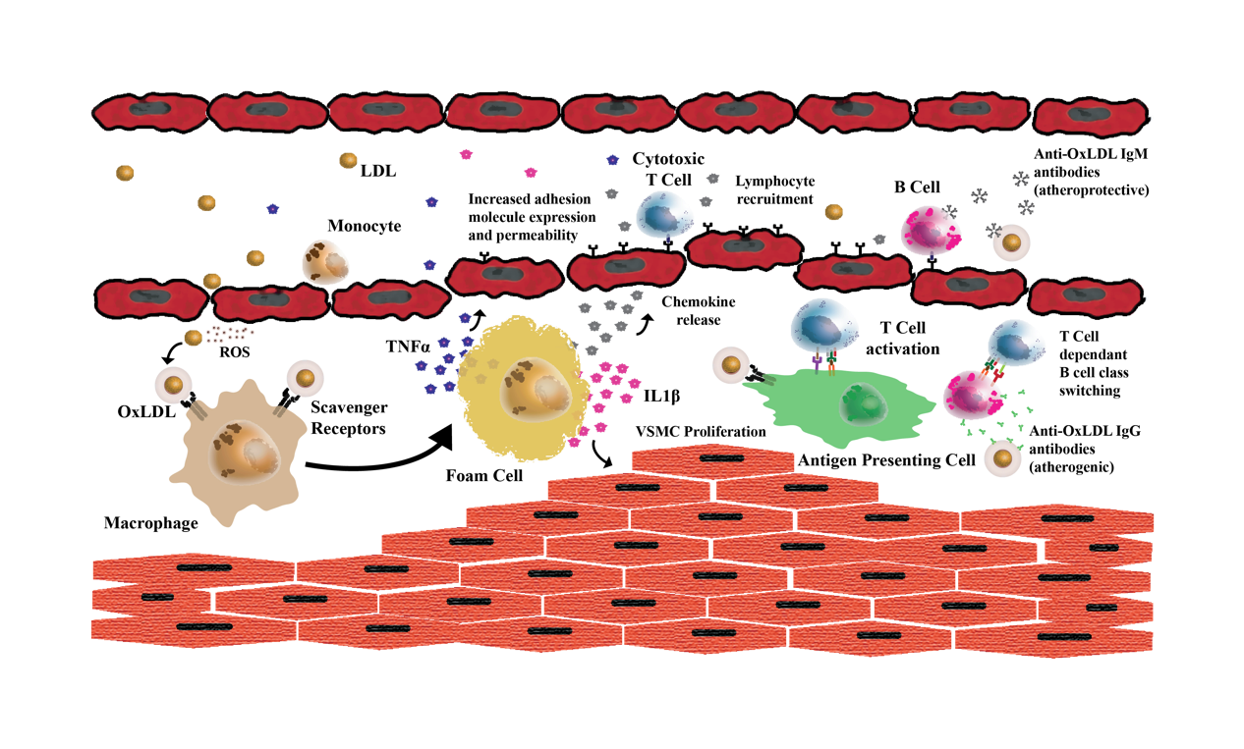
If you have a shareable, non-confidential diagram of your company’s technology please share below.
A

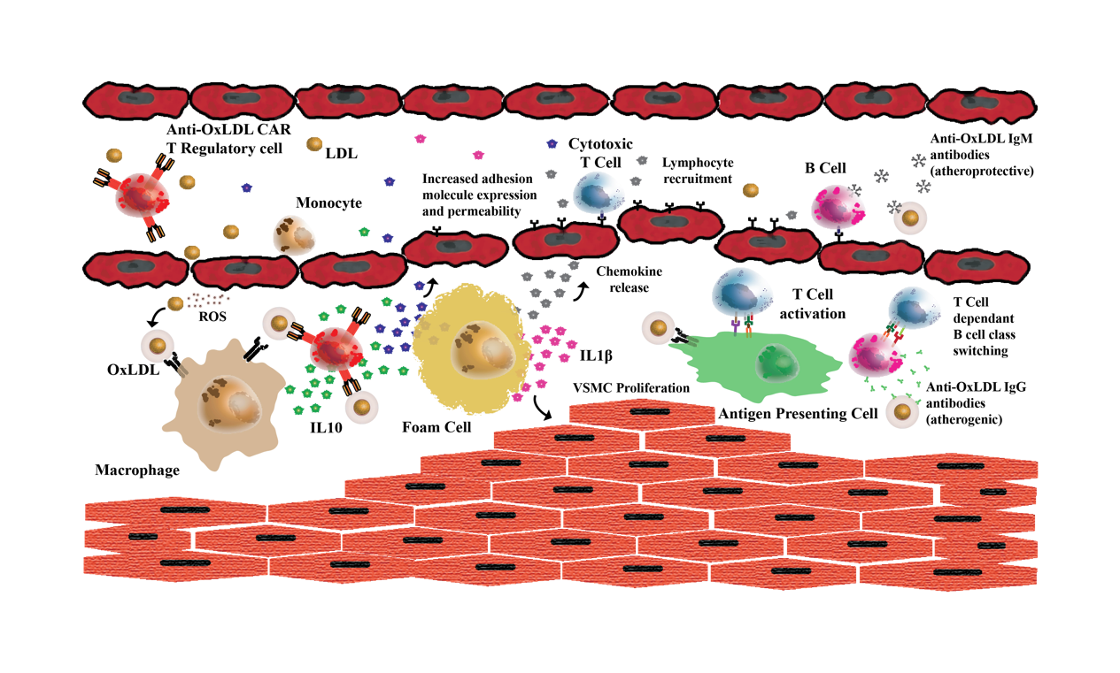

B

Pathogenesis of Atherosclerosis and Proposed anti-OxLDL T Regulatory Therapy (A) LDL deposition in the endovascular endothelium results in oxidation by reactive oxygen species (ROS). Oxidized LDL (OxLDL) is internalized by scavenger receptors on macrophages, which turn into foam cells. Foam cells release pro-inflammatory cytokines (TNFα and IL-1β) that increase adhesion molecule expression on the vascular endothelium and cause vascular smooth muscle cell (VSMC) proliferation. Chemokines are also released that recruit T cells and B cells. T cells become activated by foam cells or other antigen-presenting cells and then interact with B cells to produce anti-OxLDL immunoglobulins that are pro-atherogenic and increase inflammation. In time, a fibrous cap develops on the arterial wall, leading to plaque deposition and rupture. (B) Pathogenesis of atherosclerosis with the addition of an anti-OxLDL CAR T regulatory cell that can reduce the inflammatory response initiated by OxLDL through IL10 secretion (an anti-inflammatory molecule).

