Company Name: Peroxitech
One sentence description: Discover and develop new drugs to protect cells from death
Simplified non-technical short description (as if you are describing the company to a family member who is not an industry expert): Discovering new medications that will save people and change lives
What is the origin of the company’s name? The name is derived from Peroxidation, which means oxidative degradation leading to cell damage and death. The company is working on drug discoveries to prevent this process
What is the problem that your company addresses and how does your product solve this problem? When people are critically sick (with pneumonia, sepsis, influenza, etc..), the body’s immune system can cause an over production of ROS (Reactive Oxygen Species). ROS in healthy people acts as an important immune response to fight infections. However, in these sick patients this uncontrolled, over production of ROS, leads to significant damage to critical organs and can leads to death. One organ that is highly susceptible to ROS overproduction is the lung, when this occurs, this is called ALI (acute lung injury). There is no medication to treat ALI and once a person is diagnosed, 40% of people will die and on average, they spend over 30 days in the hospital. Building on decades of basic research, our inventors Dr. Fisher and Mr. Feinstein Ph.D. from UPENN were able to discover an earlier pathway for ROS activation. Subsequently they discovered a novel drug that blocked this pathway from activating and preventing ROS overproduction. In early research studies, this novel drug showed 70% survival (w/ novel drug) versus 0% survival (w/o novel drug). These results have never been seen before and could dramatically save thousands of lives each year.
Who are your competitors? How are you different? We do not have any competitors
Do you have any specific imagery in mind for your logo? No
Do you have any preferences of what colors to use or not to use? It helpful to have bold memorable colors and designs. Stay away from earth tones.
What adjectives would best describe your company?
What verbs would best describe your company? Lifesaving, protecting cells from death, preventing injury
What adjectives would best describe your logo? Simple, elegant designs with dimensional aspects (3D)
Who is your target audience? Physicians and investors
What kind of personality should your company project? Visionary
What is it you want to express with your logo? Future possibilities
If you are currently using a logo please include below.
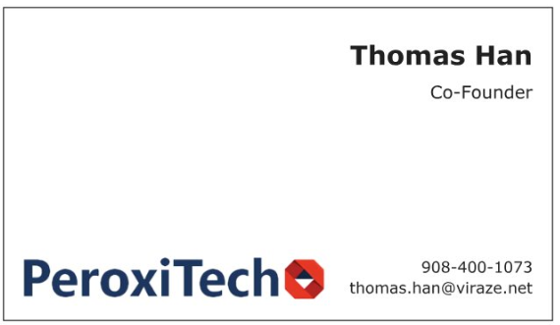
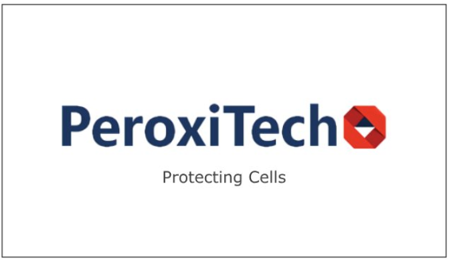
If you have a shareable, non-confidential diagram of your company’s technology please share below. See below.
