Company Name:
Trefo
One sentence description:
Trefo builds robot and machine learning systems for the forestry industry.
Simplified non-technical short description (as if you are describing the company to a family member who is not an industry expert):
What is the origin of the company’s name?
Trefo means to nourish/grow in Greek, and also includes part of the word “tree”,
What is the problem that your company addresses and how does your product solve this problem?
We are solving timber cruising, or the process to estimate the volume of timber in a forest. It is used by forest owners, investors, and managers when they buy and sell timberland, harvest, and grow trees. It is currently performed by people walking around a forest and measuring trees with a tape measure, and our product automates this process resulting in faster cruise times, cheaper costs, and more accurate volume estimates.
Who are your competitors? How are you different?
Our competitors focus on over the canopy methods such as satellites or drones that fly above canopy. These methods aren’t able to get the necessary detail and accuracy to replace traditional manual cruising methods. We differ because we fly our drones below the forest canopy and automatically navigate through the trees.
Do you have any specific imagery in mind for your logo?
Something that subtly references trees/forests, but is not overt as we plan to tackle other industries in the future.
Do you have any preferences of what colors to use or not to use?
I would prefer orange and green, but am not tied to it.
What adjectives would best describe your company?
Innovative, ambitious, fast, full-stack (hardware to software)
What verbs would best describe your company?
Fly (drone flying), compute
What adjectives would best describe your logo?
All-encompassing, global, broad, ambitious
Who is your target audience?
Tech Vcs and investors.
Forestry owners, managers which involve government agencies (US Forest Service, Bureau of Land Management, Department of Defense, state forest and parks etc.), corporate private (publicly traded companies, Timber Investment Management Organizations), and private landowners (individuals who own forests).
Future employees
What kind of personality should your company project?
(Ambitious) We are going to be the go-to robotics company that develops robot solutions for all industries (the Google/Amazon/Facebook of robotics).
(Strategic) We chose forestry as our initial target market because we feel that this industry will have the largest benefits from robotics.
(Expert) Our team consists of leading experts (PhDs, professors etc) in robotics.
What is it you want to express with your logo?
The feeling should be that “this company is doing big things”.

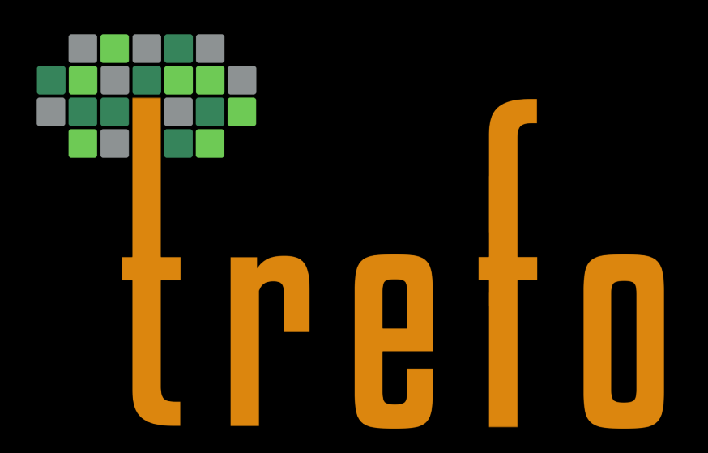
If you are currently using a logo please include below.

If you have a shareable, non-confidential diagram of your company’s technology please share below.
Our drone:
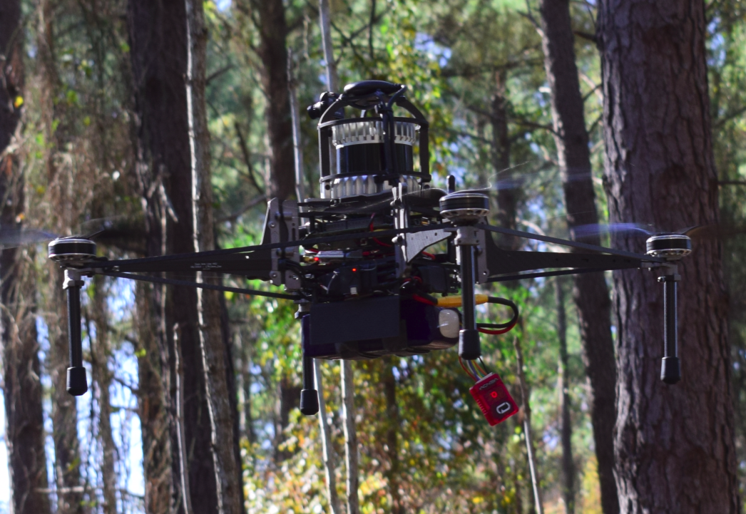

An example forest map:
